PACS ANALYSIS DOCUMENT
PT Bank of India Indonesia Tbk - BOII

TICKET REFERENCE NUMBER : TSR-1125297

ISSUE CREATION DATE : 10-DEC-2025

REOPEN DATE (If Any) :

Table of Contents
Table of Contents 2
1. Document History 3
2. Client Information 4
3. Review Information 4
4. Symptoms 4
5. Problem Description 4
6. Analysis 4
7. Alternate Recommendations to the Client 5
8. Steps for Recreation 5
9. Code Analysis 5
10. Code fix Suggestion 5
11. Supporting Screen Prints for the Problem 5
12. Expected Solution to the Problem 5
13. Action to Be Carried Out 6
14. Area details 6

Document History

Author | Version | Date Description
Krishna Kishore G | 0.1 | 10-12-2025 Initial Draft
Surendar N | 1.0 | 10-12-2025 Reviewed

Comments:
NA

Client Information

Product : transact- cmb
Priority : high
Product Release : r22
System status : prod
Database : na
Front end : na

Review Information

Analysed By : Krishna Kishore Garlapati
Reviewed By : Surendar N

Symptoms
Aging Status Is Not Settled After Manual Reset Overdue Age

Problem Description
Aging Status Is Not Settled After Manual Reset Overdue Age

Analysis
As analysed, when the user was SET the overdue status manually and after repaid the bill and during the MANUAL.RESET activity system is not updating the aging status in AA.ACCOUNT.DETAILS and AA.BILL.DETAILS is not updated with SETTLED when the bill was repaid with outstanding amount and not paid the PENALTYINT in a bill.
When a bill was repaid with total bill amount except PENALTYINT balance in a bill and its AGING STATUS was not marked as “SETTLED” and still it was updated with OVERDUE status.
System is triggering the incorrect SET-OVERDUE activity and updating the AA.ACCOUNT.DETAILS and AA.BILL.DETAILS with incorrect while doing the MANUAL.RESET activity.

Alternate Recommendations to the Client
NA

Steps for Recreation
- Take a latest R22 environment with latest updates related to AA
- Create a loan having the 2 or 3 bills which are in overdue status.
- Trigger the LENDING-SET-OVERDUE*NAB activity manually and observe the AA.ACCOUNT.DETAILS updated the manual overdue fields.
- Repay the bills with CONSTANT amount and not repaid the PENALTYINT amount and observe the BILL aging status not updated with SETTLED.
- Trigger the LENDING-MANUAL.RESET-OVERDUE and observe the incorrect ARR.AGE.STATUS in AA.ACCOUNT.DETAILS and AGING.STATUS was not updated with SETTLED in AA.BILL.DETAILS.

Code Analysis

AA.OVERDUE.CHANGE.STATUS:

575 : GOSUB DETERMINE.CHANGE.AGE.STATUS ;* Check Status Movement Set.
TAFJ Debugger-> s

700 : CHANGE.AGE.STATUS = ""
TAFJ Debugger-> S

701 : OD.POS = ""
TAFJ Debugger-> S

702 : ARR.AGE.STATUS = R.ACCOUNT.DETAILS<AA.PaymentSchedule.AccountDetails.AdArrAgeStatus>
TAFJ Debugger-> S

708 : IF NOT(ARR.AGE.STATUS) OR ARR.AGE.STATUS EQ "CUR" THEN ;* there may be some bills which are in DUE status and none of them would have aged, still we need to go ahead and update the correct next.age.date for the bills as per the current OVERDUE definition
TAFJ Debugger-> V ARR.AGE.STATU
ARR.AGE.STATU : N/A
TAFJ Debugger-> V ARR.AGE.STATUS
ARR.AGE.STATUS : (-1) NAB
TAFJ Debugger-> S

710 : END
TAFJ Debugger-> S

712 : IF ARR.AGE.STATUS NE "CUR" AND NOT(CHANGE.AGE.STATUS) THEN
TAFJ Debugger-> S

714 : LOCATE ARR.AGE.STATUS IN R.OVERDUE<AA.Overdue.Overdue.OdOverdueStatus, BT.POS, 1> SETTING OD.POS THEN
TAFJ Debugger-> S

715 : IF R.OVERDUE<AA.Overdue.Overdue.OdStatusMvmt, BT.POS, OD.POS> EQ "YES" OR MANUAL.RESET THEN ;*For manual reset activity no need to check the statusmovemnt
TAFJ Debugger-> V ARR.AGE.STATUS
ARR.AGE.STATUS : (-1) NAB
TAFJ Debugger-> S

716 : CHANGE.AGE.STATUS = 1
TAFJ Debugger-> S

717 : END
TAFJ Debugger-> S

729 : END
TAFJ Debugger-> S

730 : END
TAFJ Debugger-> S

733 : RETURN
TAFJ Debugger-> S

577 : IF CHANGE.AGE.STATUS THEN
TAFJ Debugger-> S

578 : GOSUB DETERMINE.SAME.AGE.STATUS ;* Check whether Calculated status is same as Age all bill Status.
TAFJ Debugger-> s

856 : PROCESS.FLAG = 1 ;* Flag to decide Adjust Ageing.
TAFJ Debugger-> S

858 : GOSUB CALCULATE.NEW.AGE.STATUS ;* Get the calculated aging status of unpaid bills in FM array.
TAFJ Debugger-> s

1172 : BILL.REFERENCES = "" ;* We should not pass settled bill reference, unpaid bills are anyway identified inside AA.OVERDUE.GET.NEW.AGE.STATUS routine.
TAFJ Debugger-> S

1174 : AA.Overdue.OverdueGetNewAgeStatus(ARRANGEMENT.ID,R.OVERDUE,BT.POS,BILL.REFERENCES,EFFECTIVE.DATE,NEW.AGING.STATUS,NEW.AGING.DATE,AGE.ALL.BILLS.POS)
TAFJ Debugger-> V BILL.REFERENCES
BILL.REFERENCES : (-1)
TAFJ Debugger-> S

1175 : TEMP.NEW.AGING.STATUS = NEW.AGING.STATUS ;* Copy of New Aging Statuses for raising Secondary Activity.
TAFJ Debugger-> V NEW.AGING.STATUS
NEW.AGING.STATUS : (-1) DEL
TAFJ Debugger-> V NEW.AGING.DATE
NEW.AGING.DATE : (-1) 20220525
TAFJ Debugger-> V AGE.ALL.BILLS.POS
AGE.ALL.BILLS.POS : (-1)
TAFJ Debugger-> S

1176 : TEMP.NEW.AGING.DATE = NEW.AGING.DATE ;* get the actual next ageing date for each of the bills (used for updating NXT.AGE.DATE in AA.ACCOUNT.DETAILS)
TAFJ Debugger-> S

1178 : RETURN
580 : IF PROCESS.FLAG THEN
TAFJ Debugger-> S

581 : GOSUB RECALCULATE.OVEDUE.STATUS
TAFJ Debugger-> s

1006 : RECALC.AGING.STATUS = '1'
TAFJ Debugger-> S

1007 : BEGIN CASE
TAFJ Debugger-> S

1008 : CASE PROCESS.FLAG OR UPDATE.FLAG
TAFJ Debugger-> S

1009 : BILL.POS = 1
TAFJ Debugger-> S

1010 : LOOP
TAFJ Debugger-> S

1011 : BILL.ID = ""
TAFJ Debugger-> S

1012 : BILL.ID = BILL.REFERENCES<1,BILL.POS>
TAFJ Debugger-> S

1013 : WHILE BILL.ID
TAFJ Debugger-> V BILL.ID
BILL.ID : (-1) AABILL22145V3L4F
TAFJ Debugger-> S

1014 : GOSUB GET.BILL.DETAILS ;* Get bill details for each bill.id
TAFJ Debugger-> S

1015 : TEMP.OLD.AGING.STATUS<BILL.POS> = R.BILL.DETAILS<AA.PaymentSchedule.BillDetails.BdAgingStatus, 1>
TAFJ Debugger-> S

1016 : IF R.BILL.DETAILS<AA.PaymentSchedule.BillDetails.BdAgingStatus, 1> NE "SETTLED" THEN ;* ignore bills which are settled as delinquency setup
TAFJ Debugger-> V TEMP.OLD.AGING.STATUS
TEMP.OLD.AGING.STATUS : (-1) NAB
TAFJ Debugger-> S

1017 : GOSUB GET.NEW.AGEING.STATUS ;* get the new ageing status for the bill as on the effective date
TAFJ Debugger-> s

1136 : BEGIN CASE
TAFJ Debugger-> S

1137 : CASE NOT(AGE.ALL.BILLS.POS) AND AGE.BY.DAYS
TAFJ Debugger-> S

1138 : NEW.AGING.STATUS = ''
TAFJ Debugger-> S

1139 : NEW.AGING.STATUS = TEMP.NEW.AGING.STATUS<BILL.POS>
TAFJ Debugger-> S

1143 : IF TEMP.NEW.AGING.DATE<BILL.POS> GE EFFECTIVE.DATE AND NEW.AGING.STATUS NE "DUE" THEN
TAFJ Debugger-> V NEW.AGING.STATUS
NEW.AGING.STATUS : (-1) GRC
TAFJ Debugger-> S

1144 : NEW.AGING.DATE = TEMP.NEW.AGING.DATE<BILL.POS>
TAFJ Debugger-> S

1147 : END
TAFJ Debugger-> S

1155 : END CASE
TAFJ Debugger-> S

1157 : RETURN
TAFJ Debugger-> S

1018 : GOSUB PROCESS.BILL.ACCOUNT.DETAILS ;* Process ageing/bill status update in AA.BILL.DETAILS and AA.ACCOUNT.DETAILS
TAFJ Debugger-> s

1187 : CURRENT.AGE.STATUS = ""
TAFJ Debugger-> S

1188 : BILL.AGE.STATUS = ""
TAFJ Debugger-> S

1191 : LOCATE NEW.AGING.STATUS IN R.OVERDUE<AA.Overdue.Overdue.OdOverdueStatus,BT.POS,1> SETTING NEW.OD.POS ELSE
TAFJ Debugger-> V NEW.AGING.STATUS
NEW.AGING.STATUS : (-1) GRC
TAFJ Debugger-> S

1193 : END
TAFJ Debugger-> S

1195 : BEGIN CASE
TAFJ Debugger-> S

1240 : CASE 1
TAFJ Debugger-> S

1241 : AA.Overdue.GetAgeStatus(R.OVERDUE, BILL.TYPE.IN, "", "PREV", NEW.AGING.STATUS, CURRENT.AGE.STATUS, "", "") ;* Get the Previous Ageing status based on the New Ageing Status to update in Account Details
TAFJ Debugger-> V NEW.AGING.STATUS
NEW.AGING.STATUS : (-1) GRC
TAFJ Debugger-> S

1243 : END CASE
TAFJ Debugger-> V CURRENT.AGE.STATUS
CURRENT.AGE.STATUS : (-1)
TAFJ Debugger-> S

1245 : GOSUB RECALCULATE.AGING
TAFJ Debugger-> s

1284 : IF NOT (CURRENT.AGE.STATUS) AND NEW.AGING.STATUS NE "DUE" THEN
TAFJ Debugger-> S

1285 : CURRENT.AGE.STATUS = NEW.AGING.STATUS
TAFJ Debugger-> S

1286 : END
TAFJ Debugger-> V NEW.AGING.STATUS
NEW.AGING.STATUS : (-1) GRC
TAFJ Debugger-> S

1288 : RETURN
TAFJ Debugger-> S

1246 : GOSUB UPDATE.ACCOUNT.DETAILS ;* Update the account details record
TAFJ Debugger-> s

1298 : LOCATE BILL.PAY.DATE IN R.ACCOUNT.DETAILS<AA.PaymentSchedule.AccountDetails.AdBillPayDate, 1> SETTING PAY.DT.POS THEN
TAFJ Debugger-> S

1299 : LOCATE BILL.ID IN R.ACCOUNT.DETAILS<AA.PaymentSchedule.AccountDetails.AdBillId, PAY.DT.POS, 1> SETTING BILL.ID.POS THEN
TAFJ Debugger-> S

1301 : IF AGE.BY.DAYS THEN ;* Update NEXT.AGE.DATE only if ageing is by days
TAFJ Debugger-> S

1302 : IF MANUAL.RESET AND NOT(PROCESS.TYPE EQ "REVERSE") THEN ;* During reset activity if new aging date is less than manual reset date , clear it
TAFJ Debugger-> S

1303 : IF NEW.AGING.DATE LT EFFECTIVE.DATE THEN ;* the activity shouldnt be scheduled in scheduled.activity.
TAFJ Debugger-> S

1305 : END
TAFJ Debugger-> V NEW.AGING.DATE
NEW.AGING.DATE : (-1) 20220529
TAFJ Debugger-> S

1306 : END
TAFJ Debugger-> S

1307 : R.ACCOUNT.DETAILS<AA.PaymentSchedule.AccountDetails.AdNxtAgeDate, PAY.DT.POS, BILL.ID.POS> = NEW.AGING.DATE ;* Next ageing date
TAFJ Debugger-> S

1308 : END
TAFJ Debugger-> S

1311 : IF MANUAL.RESET AND PROCESS.TYPE EQ "REVERSE" THEN
TAFJ Debugger-> S

1313 : END
TAFJ Debugger-> S

1315 : IF TEMP.NEW.AGING.STATUS<BILL.POS> THEN ;* blank chaser date, only if AGEING status is recalculated for the bill
TAFJ Debugger-> S

1316 : R.ACCOUNT.DETAILS<AA.PaymentSchedule.AccountDetails.AdChaserDate, PAY.DT.POS, BILL.ID.POS> = "" ;* To clear the Old Chaser Dates in schedule Activity.
TAFJ Debugger-> S

1317 : END
TAFJ Debugger-> S

1320 : IF NOT(MANUAL.RESET AND PROCESS.TYPE EQ "REVERSE") THEN
TAFJ Debugger-> S

1321 : R.ACCOUNT.DETAILS<AA.PaymentSchedule.AccountDetails.AdAgingStatus, PAY.DT.POS, BILL.ID.POS> = CURRENT.AGE.STATUS
TAFJ Debugger-> V CURRENT.AGE.STATUS
CURRENT.AGE.STATUS : (-1) GRC
TAFJ Debugger-> S

1322 : GOSUB UPDATE.CURRENT.AGE.STATUS
TAFJ Debugger-> s

1414 : CURRENT.AGE.STATUS = R.ACCOUNT.DETAILS<AA.PaymentSchedule.AccountDetails.AdAgingStatus, PAY.DT.POS, BILL.ID.POS>
TAFJ Debugger-> S

1415 : BILL.STATUS = R.ACCOUNT.DETAILS<AA.PaymentSchedule.AccountDetails.AdBillStatus,PAY.DT.POS,BILL.ID.POS>
TAFJ Debugger-> V CURRENT.AGE.STATUS
CURRENT.AGE.STATUS : (-1) GRC
TAFJ Debugger-> S

1416 : BILL.SETTLE.STATUS = R.ACCOUNT.DETAILS<AA.PaymentSchedule.AccountDetails.AdSetStatus,PAY.DT.POS,BILL.ID.POS>
TAFJ Debugger-> V BILL.STATUS
BILL.STATUS : (-1) AGING
TAFJ Debugger-> S

1418 : IF CURRENT.AGE.STATUS EQ "" THEN ;* If ageing status is GRA or "", update Bill status as "DUE"
TAFJ Debugger-> V BILL.SETTLE.STATUS
BILL.SETTLE.STATUS : (-1) UNPAID
TAFJ Debugger-> V CURRENT.AGE.STATUS
CURRENT.AGE.STATUS : (-1) GRC
TAFJ Debugger-> S

1420 : END
TAFJ Debugger-> S

1421 : IF NEW.AGING.STATUS EQ "DUE" THEN ;* For "DUE" bill, Bill status is updated as Null, GRA bill will have Bill status as "DUE" (to differenciate GRA and DUE bill for Selection)
TAFJ Debugger-> V NEW.AGING.STATUS
NEW.AGING.STATUS : (-1) DEL
TAFJ Debugger-> S

1423 : END
TAFJ Debugger-> S

1424 : RET.ERROR = ""
TAFJ Debugger-> S

1425 : AA.PaymentSchedule.UpdateBill(ARRANGEMENT.ID, "UPDATE", BILL.PAY.DATE, "", "", "", "", BILL.ID, BILL.STATUS, BILL.SETTLE.STATUS, CURRENT.AGE.STATUS, RET.ERROR)
TAFJ Debugger-> V BILL.SETTLE.STATUS
BILL.SETTLE.STATUS : (-1) UNPAID
TAFJ Debugger-> V CURRENT.AGE.STATUS
CURRENT.AGE.STATUS : (-1) DEL
TAFJ Debugger-> V BILL.STATUS
BILL.STATUS : (-1) AGING
TAFJ Debugger-> S

1427 : IF RET.ERROR THEN
TAFJ Debugger-> S

1429 : END
TAFJ Debugger-> S

1431 : RETURN
TAFJ Debugger-> S

1323 : END
TAFJ Debugger-> S

1324 : END
TAFJ Debugger-> S

1325 : END
TAFJ Debugger-> S

1327 : RETURN
TAFJ Debugger-> S

1248 : RETURN
TAFJ Debugger-> S

1019 : END
TAFJ Debugger-> S

1020 : BILL.POS = BILL.POS+1
TAFJ Debugger-> S

1021 : REPEAT
TAFJ Debugger-> S

1011 : BILL.ID = ""
TAFJ Debugger-> S

1012 : BILL.ID = BILL.REFERENCES<1,BILL.POS>
TAFJ Debugger-> S

1013 : WHILE BILL.ID
TAFJ Debugger-> S

1027 : END CASE
TAFJ Debugger-> S

1029 : IF CURRENT.ACTIVITY MATCHES "WRITE.OFF":@VM:"WRITE.OFF.BILL" OR REPAID.BILL.REFERENCES OR UNPAID.BILL.REFERENCES THEN
TAFJ Debugger-> S

1030 : GOSUB CHECK.REQUIRE.RESUME.ARRANGEMENT ;* Check the resume activity is need to trigger.
TAFJ Debugger-> s

1050 : OLD.OD.STATUS = AA.Framework.getAccountDetailsSave()<AA.PaymentSchedule.AccountDetails.AdArrAgeStatus>
TAFJ Debugger-> S

1055 : LOCATE OLD.OD.STATUS IN R.OVERDUE<AA.Overdue.Overdue.OdOverdueStatus,BT.POS,1> SETTING OLD.POS THEN
TAFJ Debugger-> V OLD.OD.STATUS
OLD.OD.STATUS : (-1) NAB
TAFJ Debugger-> S

1056 : IF R.OVERDUE<AA.Overdue.Overdue.OdSuspend,BT.POS,OLD.POS> EQ "YES" OR MANUAL.RESET THEN
TAFJ Debugger-> S

1057 : GOSUB CHECK.ALL.AGE.STATUS
TAFJ Debugger-> s

1082 : BEGIN CASE
TAFJ Debugger-> S

1084 : CASE NOT(RECALC.AGING.STATUS) OR TEMP.NEW.AGING.STATUS
TAFJ Debugger-> S

1085 : RESUME.ACT = 1
TAFJ Debugger-> S

1093 : END CASE
TAFJ Debugger-> S

1095 : AGE.STATUS.CNT = DCOUNT(TEMP.NEW.AGING.STATUS,@FM)
TAFJ Debugger-> S

1096 : AGE.CNT = 1
TAFJ Debugger-> S

1098 : LOOP
TAFJ Debugger-> S

1099 : ODSTATUS = ""
TAFJ Debugger-> S

1100 : WHILE AGE.CNT LE AGE.STATUS.CNT AND RESUME.ACT
TAFJ Debugger-> S

1101 : ODSTATUS = TEMP.NEW.AGING.STATUS<AGE.CNT>
TAFJ Debugger-> S

1102 : LOCATE ODSTATUS IN R.OVERDUE<AA.Overdue.Overdue.OdOverdueStatus,BT.POS,1> SETTING ODPOS THEN
TAFJ Debugger-> S

1103 : IF R.OVERDUE<AA.Overdue.Overdue.OdSuspend,BT.POS,ODPOS> EQ "YES" THEN
TAFJ Debugger-> S

1105 : END
TAFJ Debugger-> S

1106 : END
TAFJ Debugger-> S

1107 : AGE.CNT = AGE.CNT + 1
TAFJ Debugger-> S

1108 : REPEAT
TAFJ Debugger-> S

1099 : ODSTATUS = ""
TAFJ Debugger-> S

1100 : WHILE AGE.CNT LE AGE.STATUS.CNT AND RESUME.ACT
TAFJ Debugger-> S

1110 : RETURN
TAFJ Debugger-> S

1064 : END
TAFJ Debugger-> S

1067 : END
TAFJ Debugger-> S

1069 : IF RESUME.ACT AND NOT(RESUME.PROCESS) THEN
TAFJ Debugger-> V RESUME.ACT
RESUME.ACT : (-1) 1
TAFJ Debugger-> S

1070 : GOSUB ADD.RESUME.ACTIVITY
TAFJ Debugger-> s

1118 : AAA.REC = "" ;* construct Arrangement activity record
TAFJ Debugger-> S

1119 : NEW.ACTIVITY.ID = AF.Framework.getActivityId()<AA.Framework.ActProductLine>:AA.Framework.Sep:"RESUME":AA.Framework.Sep:"ARRANGEMENT" ;* New RESUME-ARR activity
TAFJ Debugger-> S

1120 : AAA.REC<AA.Framework.ArrangementActivity.ArrActArrangement> = ARRANGEMENT.ID
TAFJ Debugger-> V NEW.ACTIVITY.ID
NEW.ACTIVITY.ID : (-1) LENDING-RESUME-ARRANGEMENT
TAFJ Debugger-> S

1121 : AAA.REC<AA.Framework.ArrangementActivity.ArrActActivity> = NEW.ACTIVITY.ID
TAFJ Debugger-> S

1122 : AAA.REC<AA.Framework.ArrangementActivity.ArrActEffectiveDate> = EFFECTIVE.DATE ;* Repayment Date.
TAFJ Debugger-> S

1123 : AAA.REC<AA.Framework.ArrangementActivity.ArrActLinkedActivity> = ARR.ACTIVITY.ID
TAFJ Debugger-> S

1125 : AA.Framework.SecondaryActivityManager("APPEND.TO.LIST", AAA.REC) ;*Append the secondary activity to a common list
TAFJ Debugger-> S

1127 : RETURN
TAFJ Debugger-> S

1071 : RESUME.PROCESS = 1
TAFJ Debugger-> S

1072 : END
TAFJ Debugger-> S

1074 : RETURN
TAFJ Debugger-> S

1031 : END
TAFJ Debugger-> S

1033 : IF NOT(RET.ERROR) AND (BILL.REFERENCES OR MANUAL.RESET.REPAID.BILLS) THEN
TAFJ Debugger-> S

1036 : GOSUB REPLAY.AGEING.ACTIVITIES ;* initiate LENDING-AGE-OVERDUE*new.status as secondary activity
TAFJ Debugger-> S

1037 : GOSUB WRITE.ACCOUNT.DETAILS ;* Write AA.ACCOUNT.DETAILS record
TAFJ Debugger-> S

Code fix Suggestion
System should update the ARR.AGE.STATUS as “CUR” instead of GRC since the bill was repaid with CONSTANT amount and AGEING status field should update with “SETTLED”.

Supporting Screen Prints for the Problem

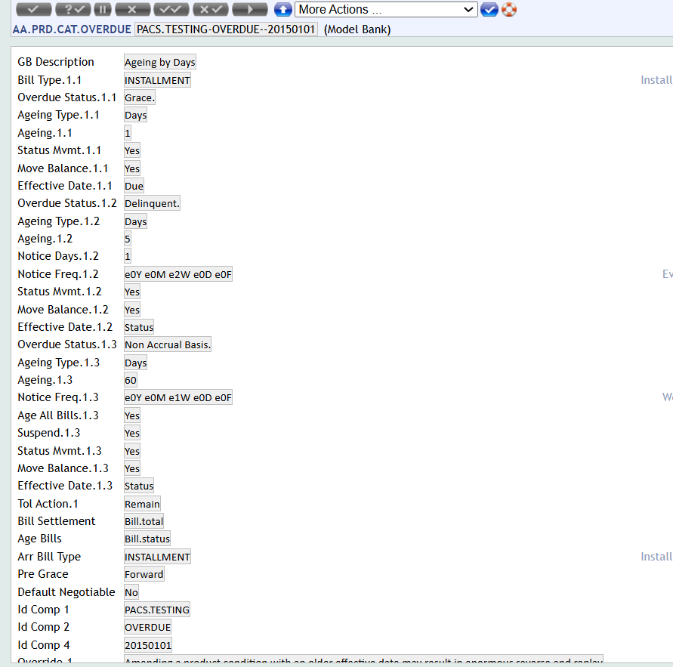
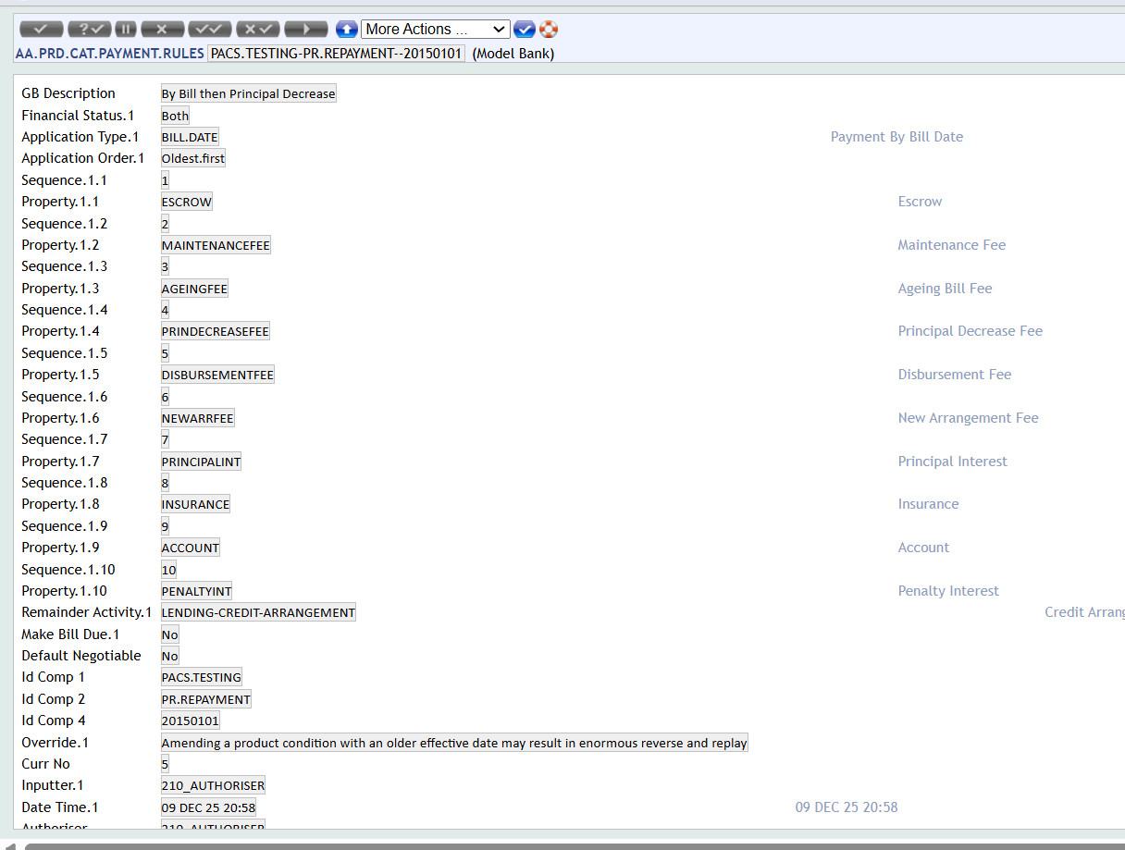
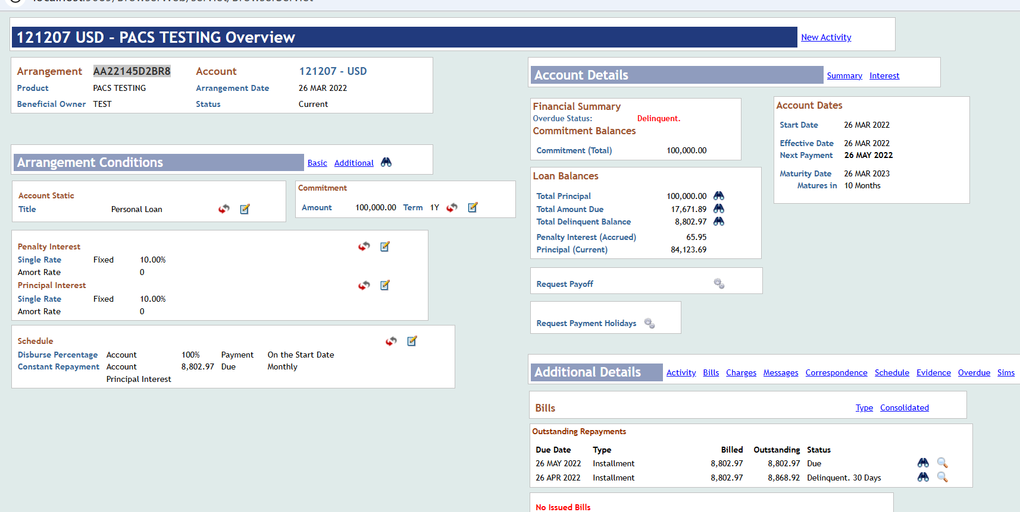
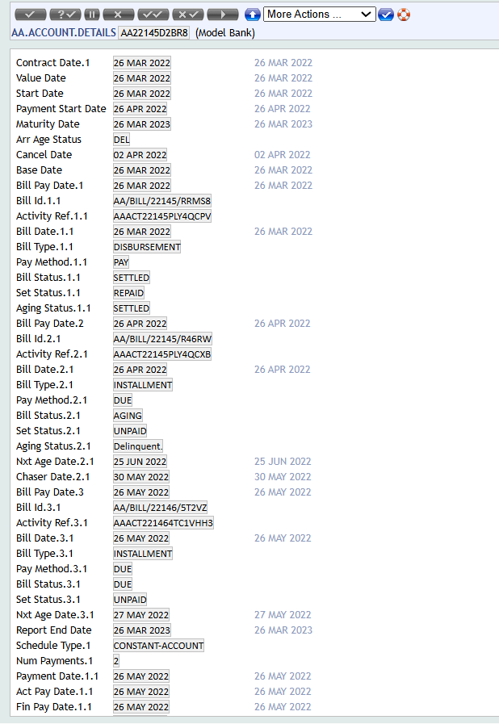
Triggered the LENDING-SET-ACTIVITY*NAB manually.
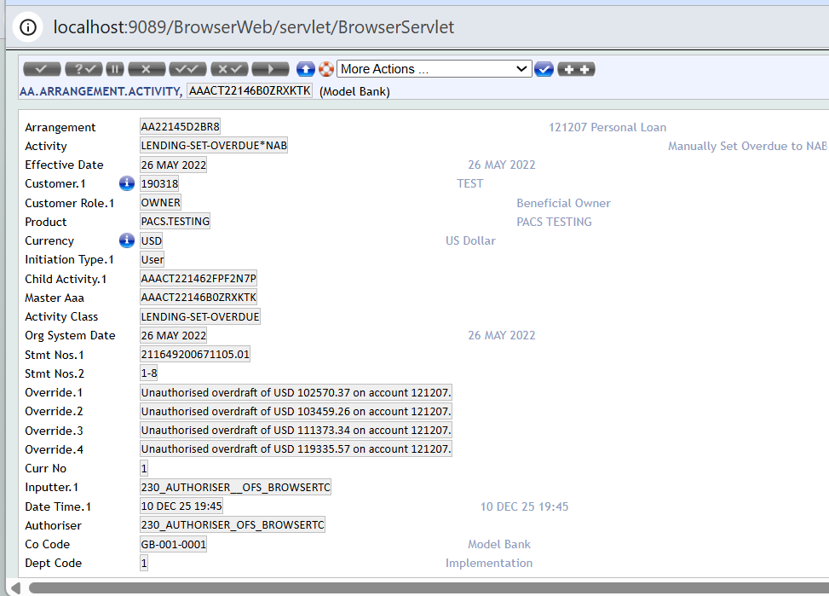
Repai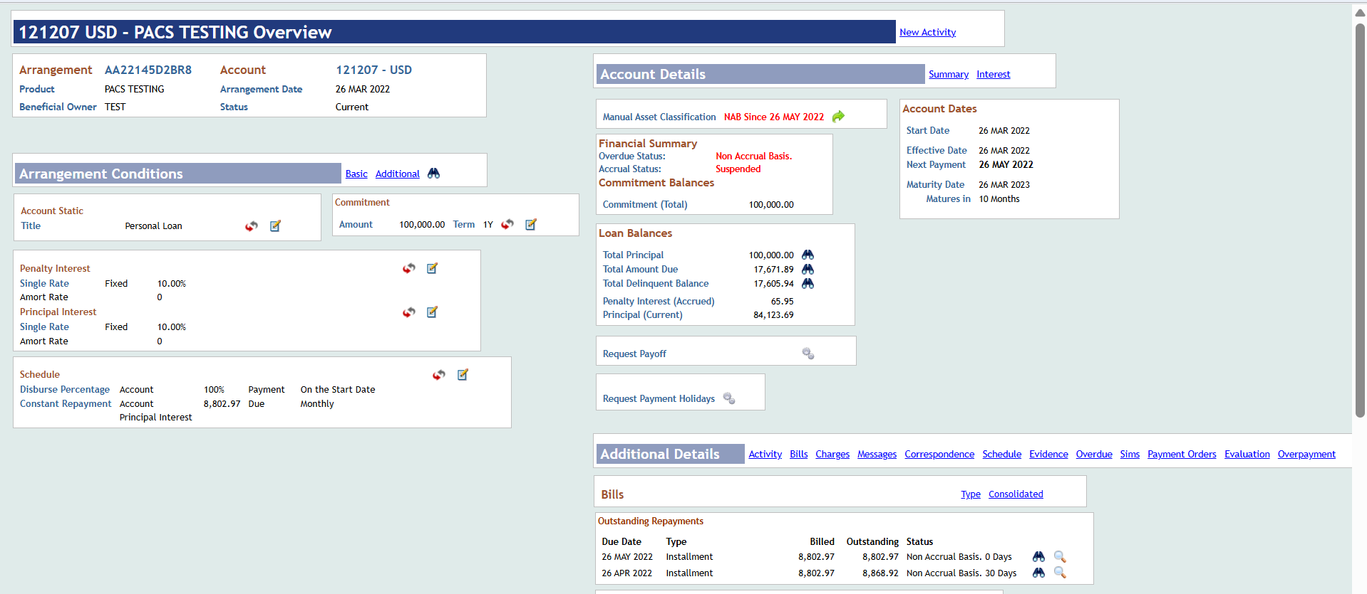
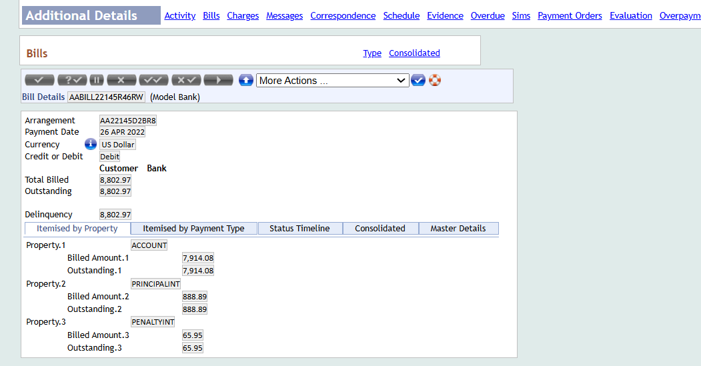
Repaid the constant amount and not paid the PENALTYINT amount.
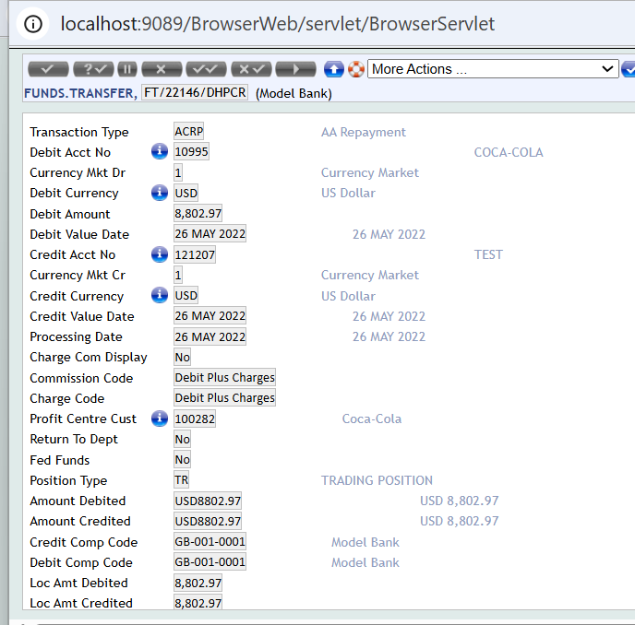
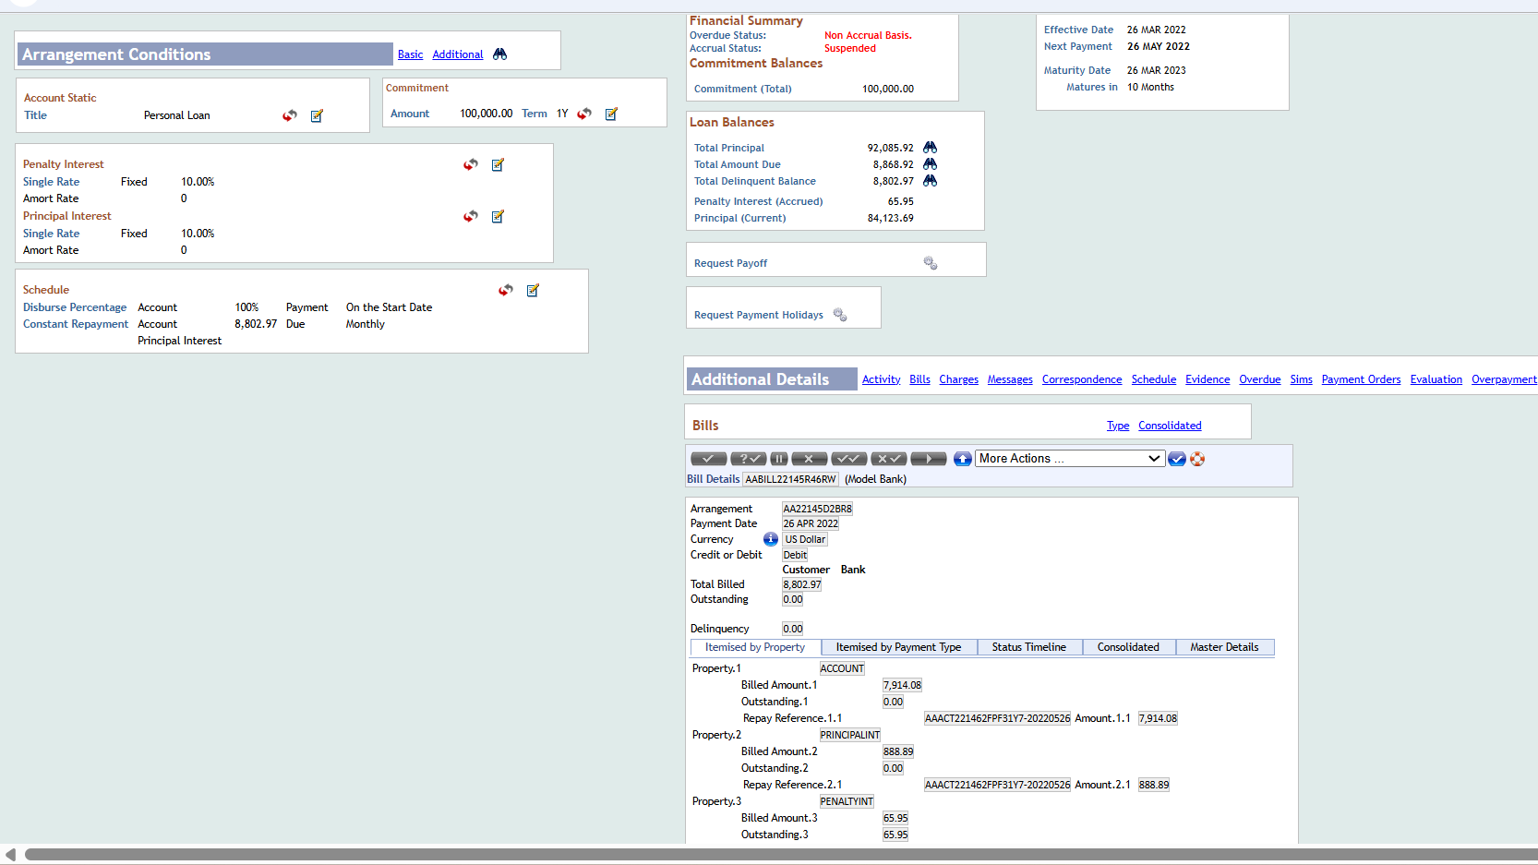
Trigger the LENDING-MANUAL.RESET-OVERDUE and it should recalculate based on overdue setup.

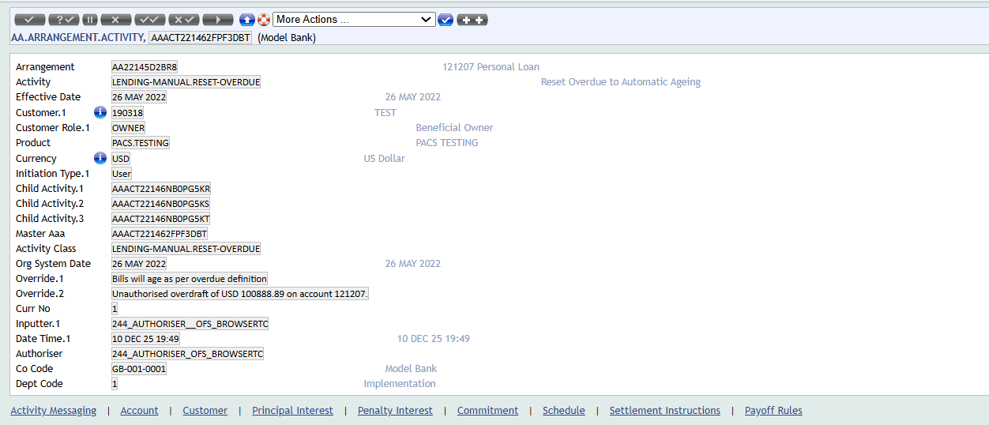
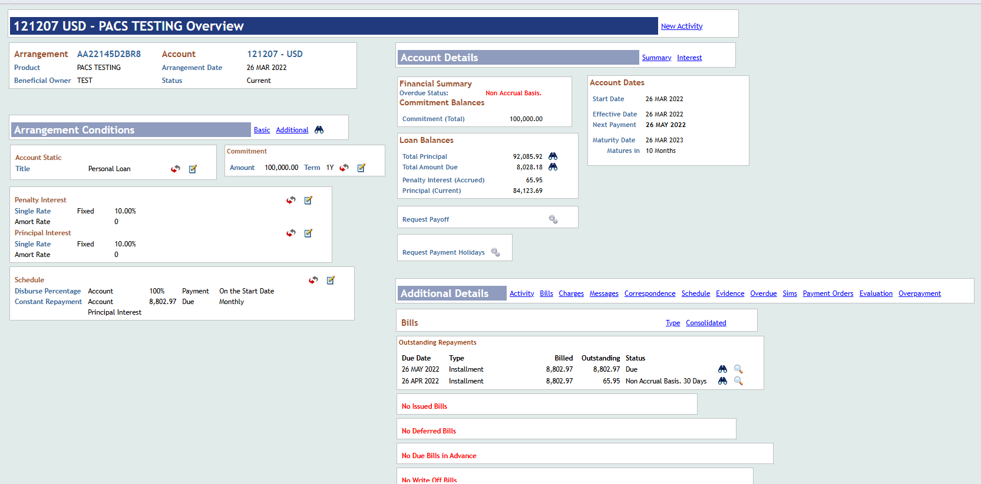
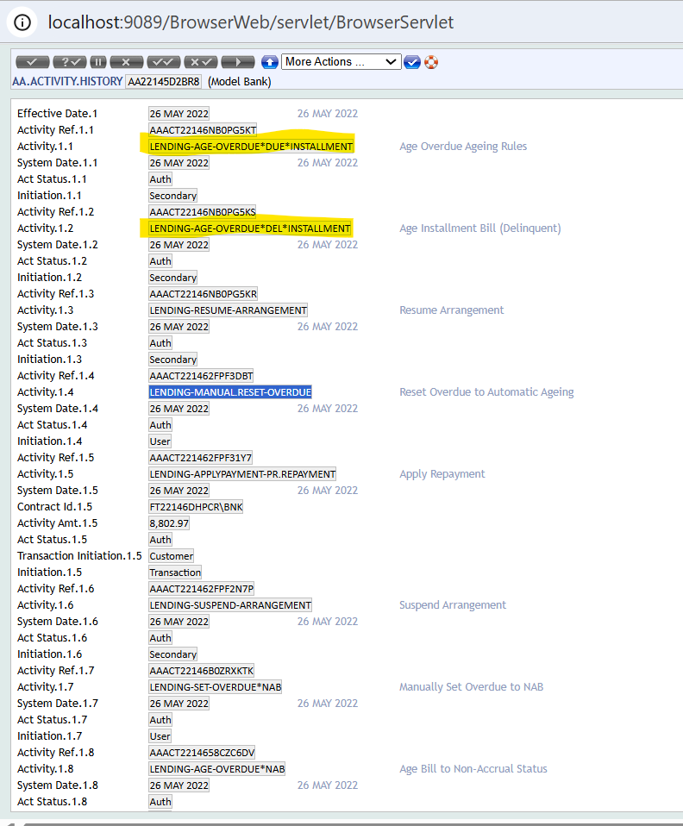
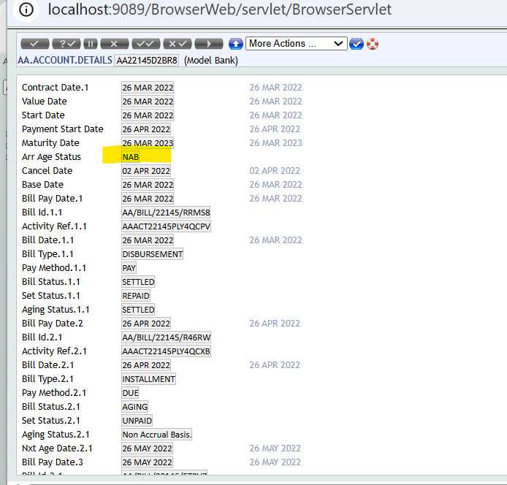
AA.BILL.DETAILS:
Expecting the AGING.STATUS to be updated as “SETTLED” in both AA.ACCOUNT.DETAILS for the bill and AA.BILL.DETAILS.
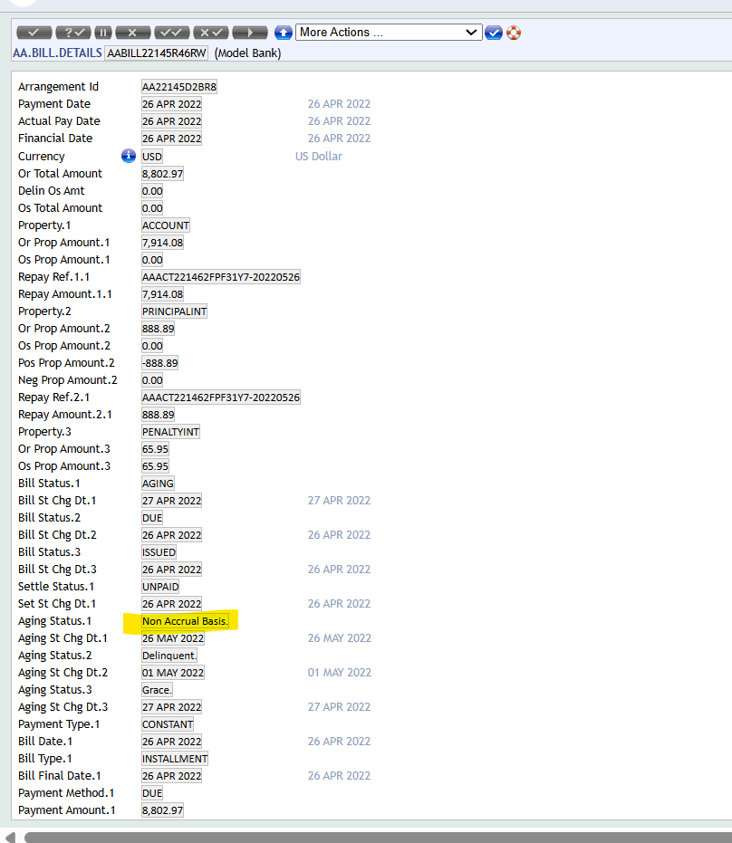

Expected Solution to the Problem
This was identified as bug and should be fixed in R22 Release

Action to Be Carried Out
NA

Area details
Server Information : NA
User name : NA
Password : NA
Backup available until : NA
Tar Backup Details : NA

*Template History (in footer) only applicable for templates and checklists

